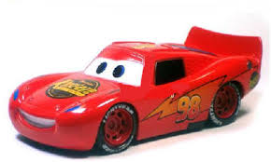

Lighting Mc Queen is a cartoon character based car. Children love to play with this unique car.

Gift your children this beautiful racing car to cheer them up.

Product: Lighting Mc Queen

Price: 1300 PKR

CONTACT US: Address: Aptech Metro Star Gate Karachi

Email: feedback@aptech-education.com.pk